**Editing text on a page**

1. Log into the website at <http://outreach.cs.dal.ca/daycare/wp-login.php> using the username “admin” and the password “SouthEnd2016!”  
   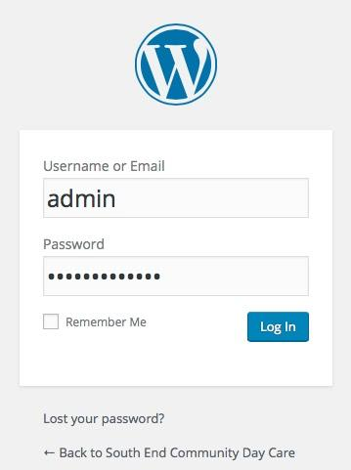
2. Hover over “Pages” in the Dashboard and select “All Pages”  
   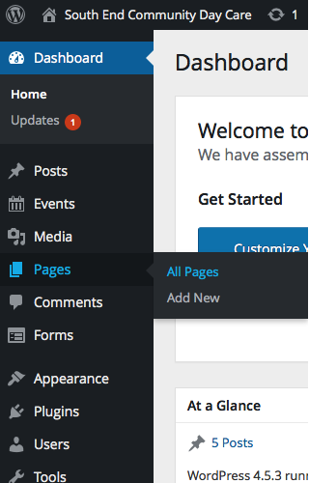
3. Hover over the name of the page that contains the text that you want to edit and then click the “Edit” option under it  
   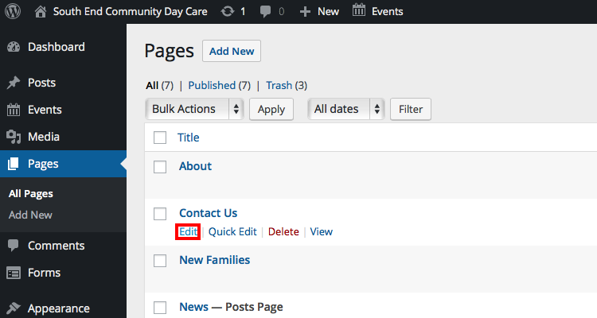
4. In the textbox, write what you would like to appear on the website page under the visual tab, and press “Update”  
   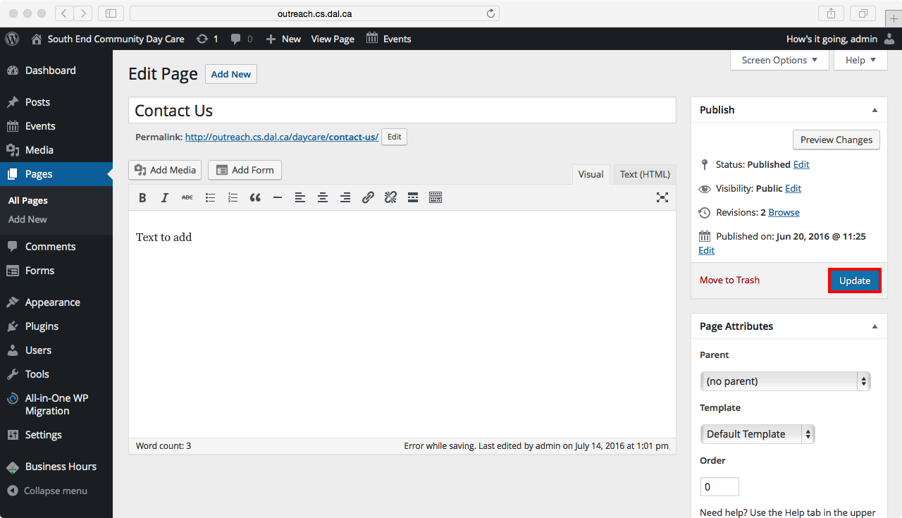

**Adding images**

1. Log into the website at <http://outreach.cs.dal.ca/daycare/wp-login.php> using the username “admin” and the password “SouthEnd2016!”  
   
2. Hover over “Pages” in the Dashboard and select “All Pages”  
   
3. Hover over the name of the page where you would like to insert the image and press “Edit”  
   
4. Press the button that says “Add Media” to add the image.  
   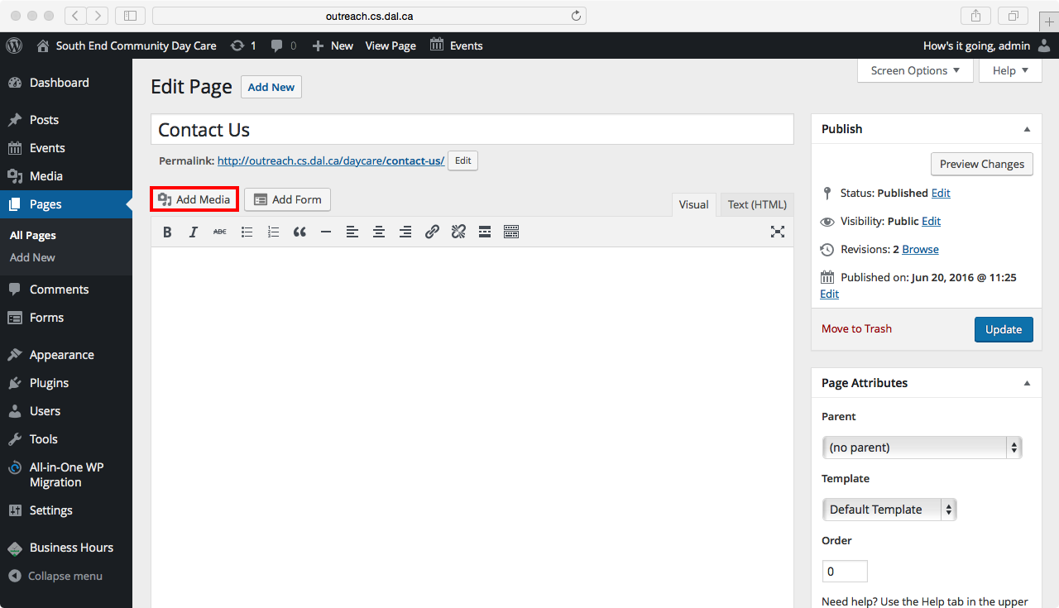
5. Select the “Upload Files” tab and press “Select Files”.  
   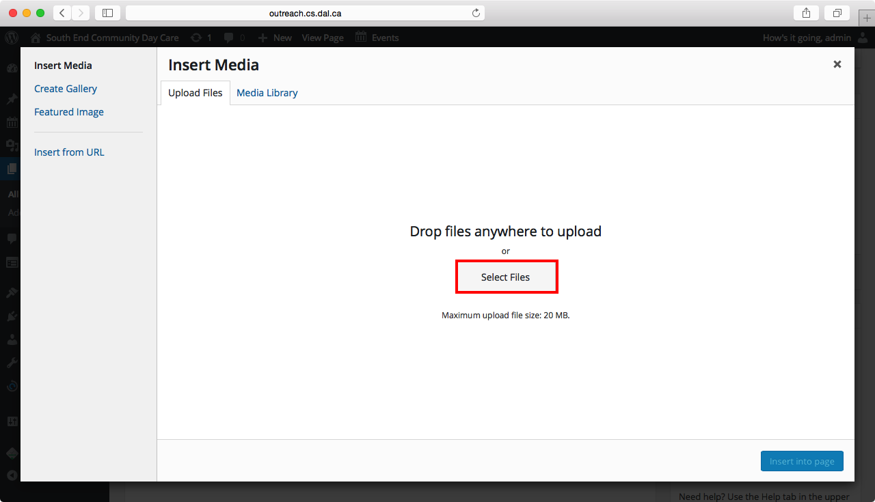
6. Find the image file in your files and select it by pressing “Choose”  
   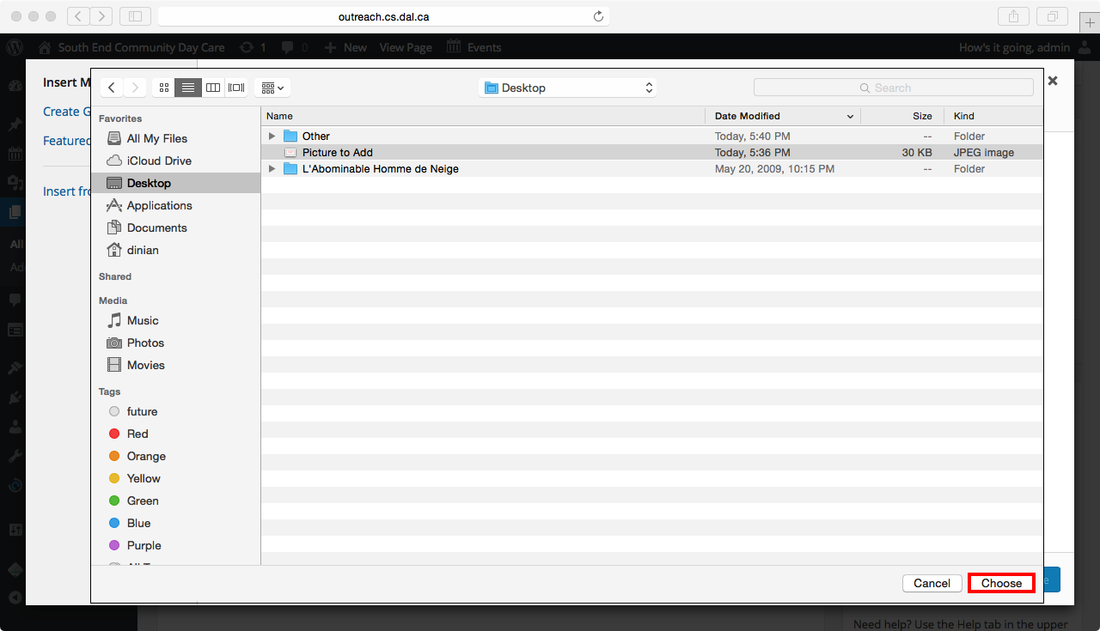
7. Add a caption if you would like some text written under the image.  
   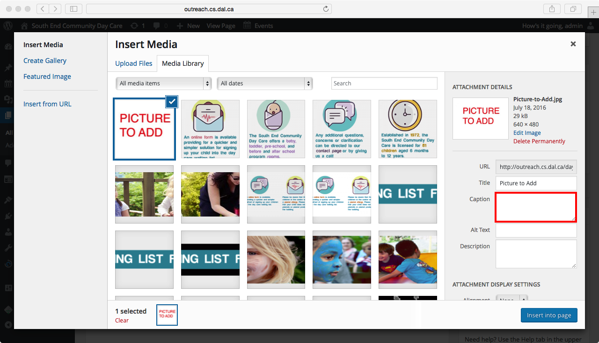
8. After the image has been uploaded, press “Insert into page”  
   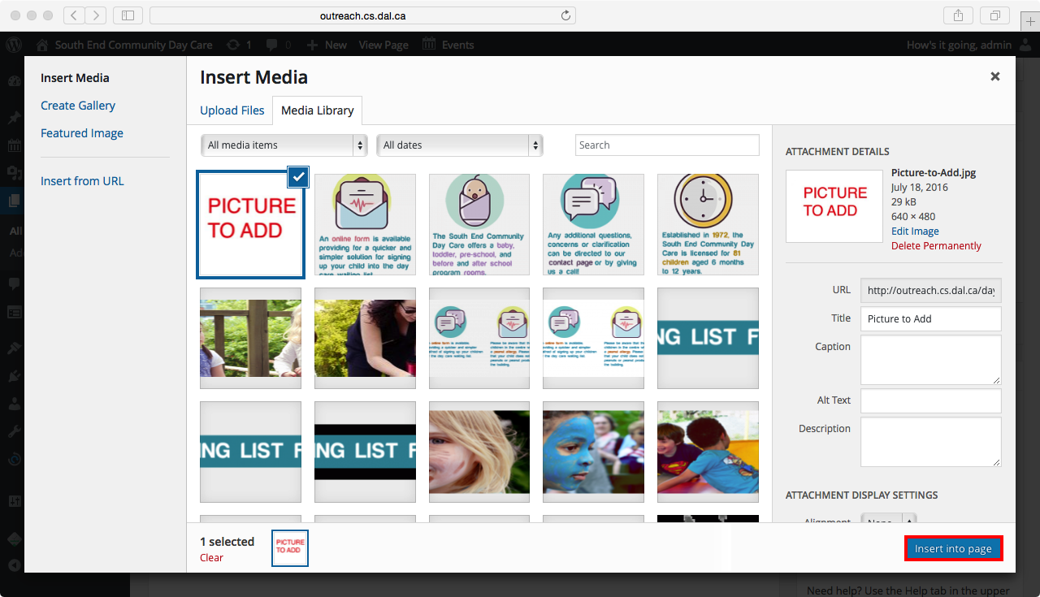
9. Press “Update” on the right side to update the webpage and insert the image onto the webpage.  
   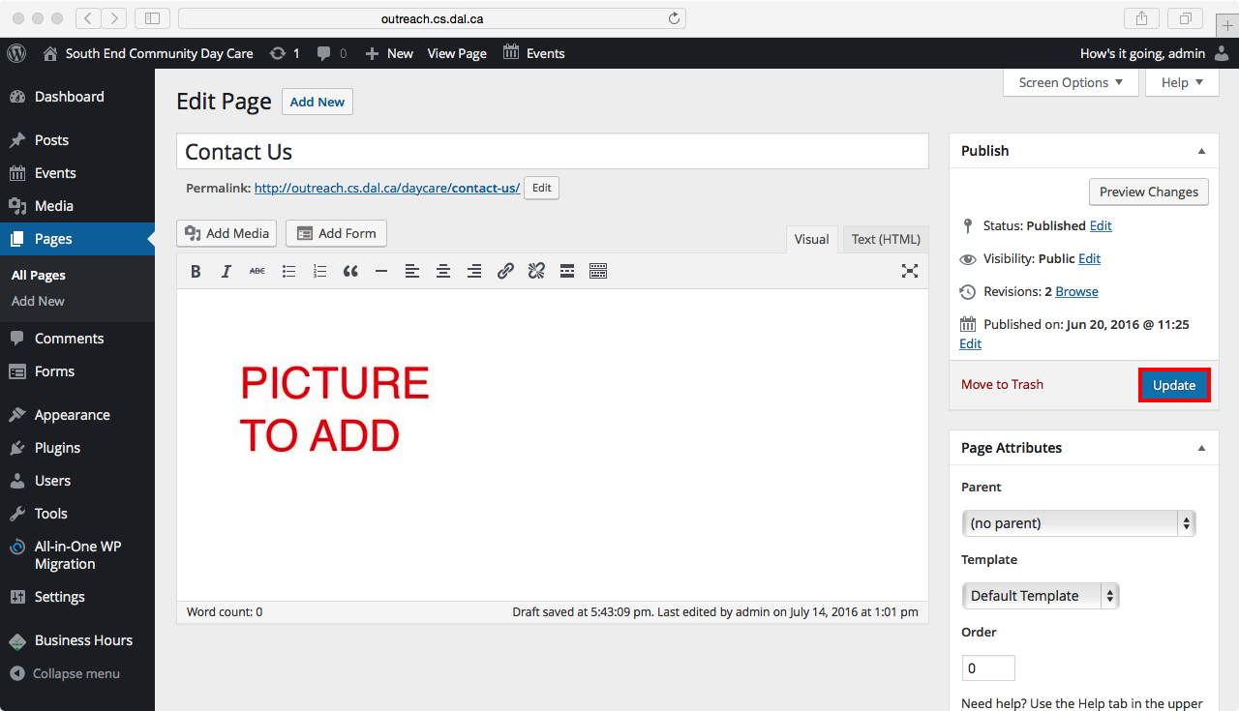

**Removing images**

1. Log into the website at <http://outreach.cs.dal.ca/daycare/wp-login.php> using the username “admin” and the password “SouthEnd2016!”  
   
2. Hover over “Pages” in the Dashboard and select “All Pages”  
   
3. Hover over the name of the page that contains the image that you would like to remove and press “Edit”.   
   
4. Highlight the image in the text field and press Backspace to remove it from the page.  
   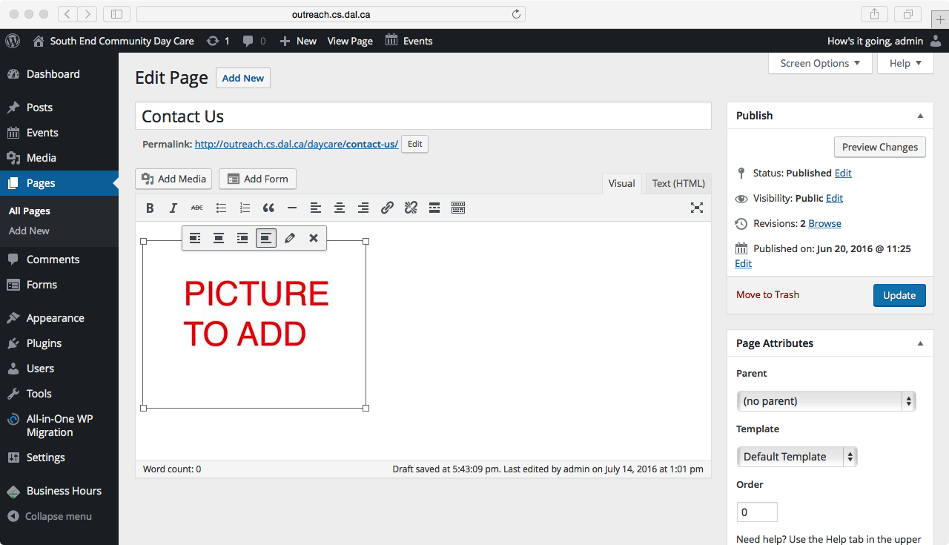
5. Press “Update” on the right side to update the webpage and remove the image from the webpage.  
   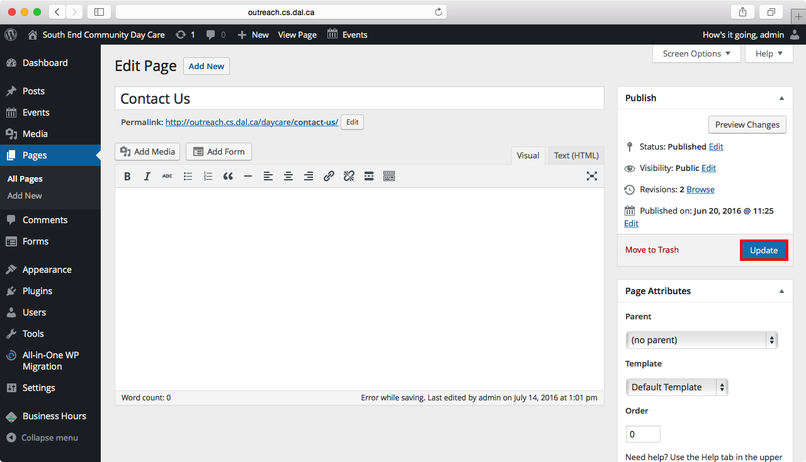

**Changing the password**

1. Log into the website at <http://outreach.cs.dal.ca/daycare/wp-login.php> using the usernme “admin” and the password “SouthEnd2016!”  
   
2. Hover over “Users” in the Dashboard and select “All Users”  
   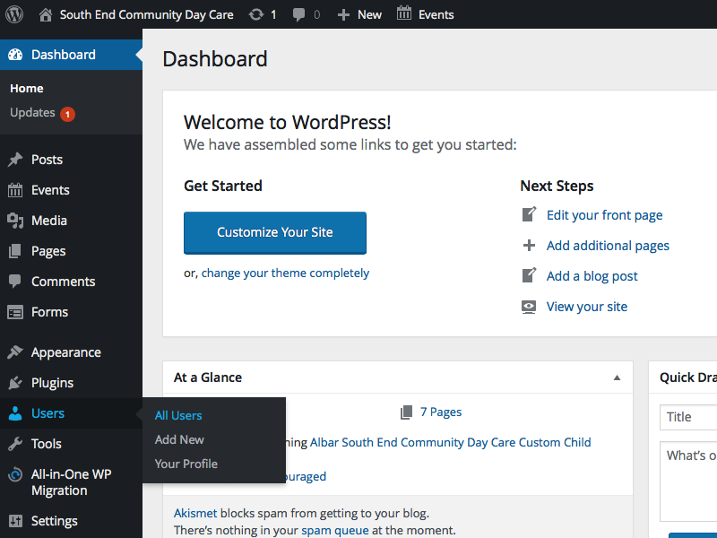
3. Scroll down and click on “Generate Password” in the Account Management section.  
   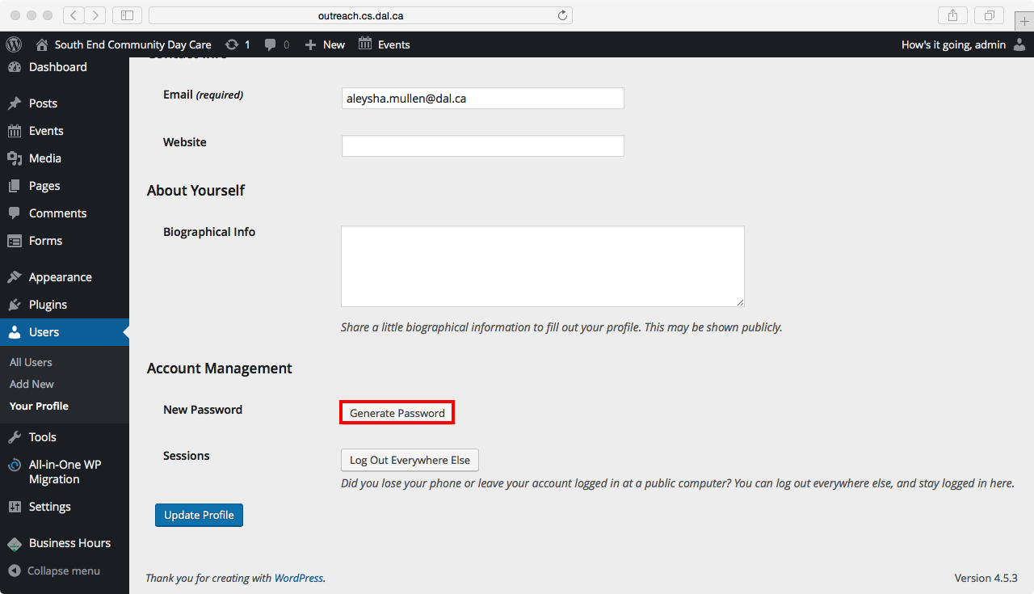
4. Enter a new password that has a “Strong” strength and press “Update Profile” to save the password change.  
   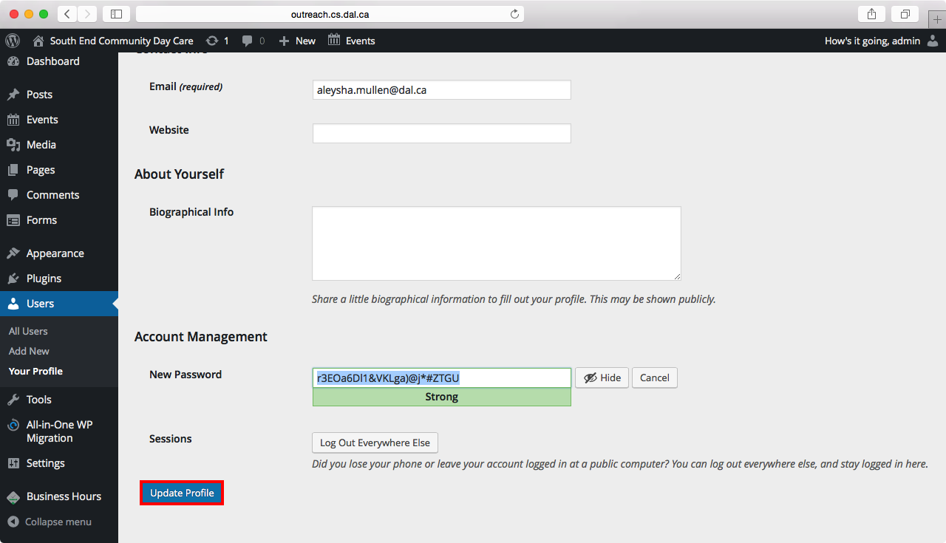

**Updating plugins**

1. Log into the website at <http://outreach.cs.dal.ca/daycare/wp-login.php> using the username “admin” and the password “SouthEnd2016!”  
   
2. Hover over “Plugins” in the Dashboard and select “Installed Plugins”  
   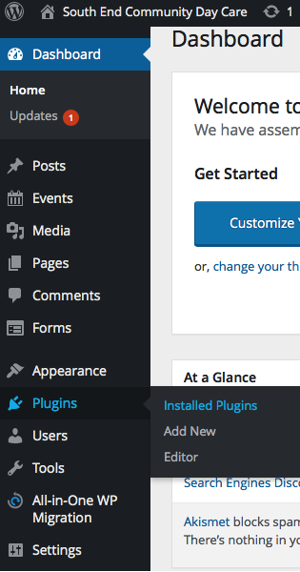
3. If you would like to update all the plugins that need updating all at the same time, click Bulk Actions.  
   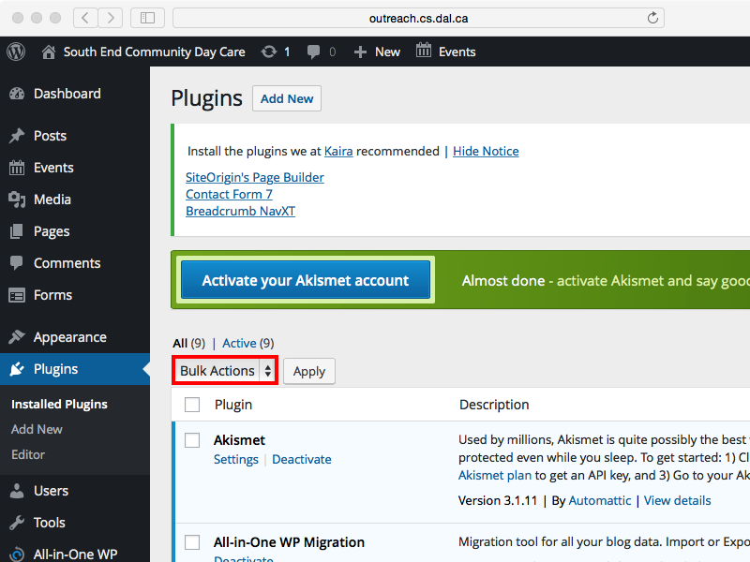
4. From the dropdown menu, select Update.  
   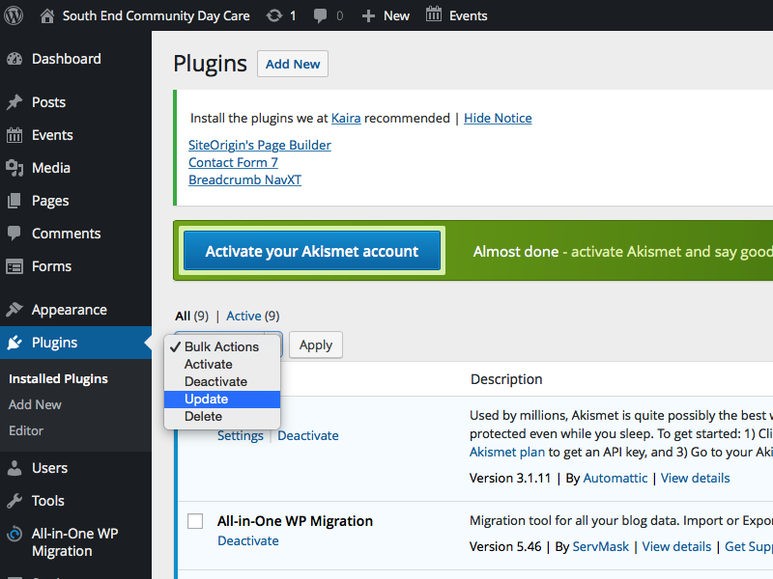
5. Click on “Apply” to update all the plugins  
   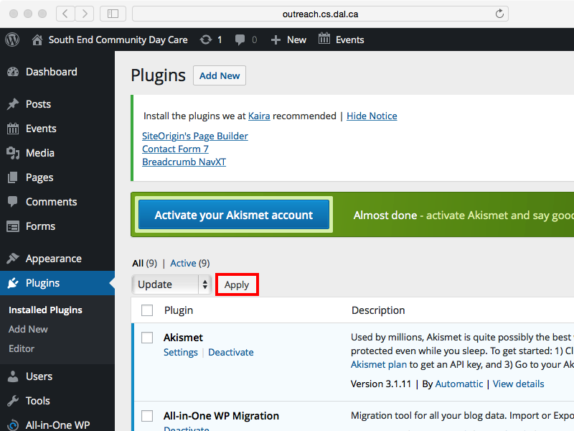
6. Otherwise, if you would like to update just one plugin, select “Update” from the list of selections under the name of the plugin.  
   